Verification and Validation

©Ian Sommerville 2004 Software Engineering, 7th edition. Chapter 22 Slide 1

Objectives

- To introduce software verification and validation and to discuss the distinction between them
- To describe the program inspection process and its role in V & V
- To explain static analysis as a verification technique
- To describe the Cleanroom software development
process

©Ian Sommerville 2004 Software Engineering, 7th edition. Chapter 22 Slide 2

Topics covered

- Verification and validation planning
- Software inspections
- Automated static analysis
- Cleanroom software development

©Ian Sommerville 2004 Software Engineering, 7th edition. Chapter 22 Slide 3

Verification vs validation

- Verification:
"Are we building the product right?”
- The software should conform to its specification.
- Validation:
"Are we building the right product?”
- The software should do what the user really requires.

©Ian Sommerville 2004 Software Engineering, 7th edition. Chapter 22 Slide 4

The V & V process

- Is a whole life-cycle process - V & V must be applied at each stage in the software process.
- Has two principal objectives
  - The discovery of defects in a system;
  - The assessment of whether or not the system is useful and useable in an operational situation.

©Ian Sommerville 2004 Software Engineering, 7th edition. Chapter 22 Slide 5

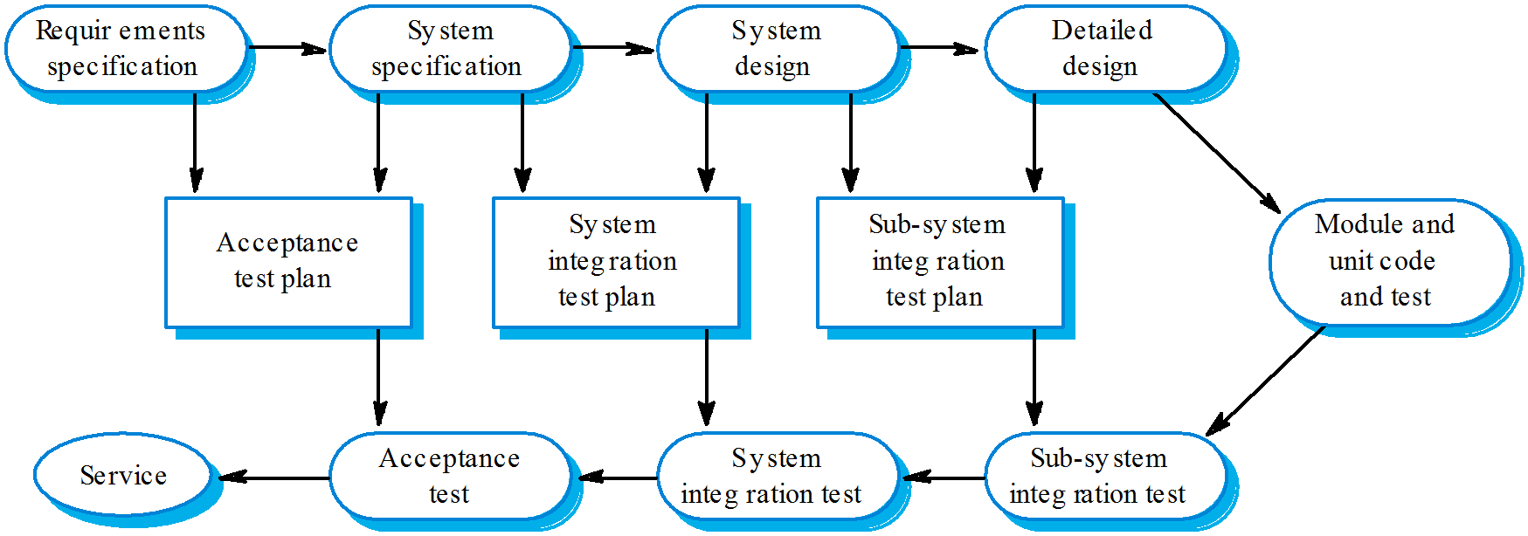The V-model of development

©Ian Sommerville 2004 Software Engineering, 7th edition. Chapter 22 Slide 6

V& V goals

- Verification and validation should establish confidence that the software is fit for purpose.
- This does NOT mean completely free of defects.
- Rather, it must be good enough for its intended use and the type of use will determine the degree of confidence that is needed.

©Ian Sommerville 2004 Software Engineering, 7th edition. Chapter 22 Slide 7

V & V confidence

- Depends on system’s purpose, user expectations and marketing environment
  - Software function
    - The level of confidence depends on how critical the software is to an organisation.
  - User expectations
    - Users may have low expectations of certain kinds of
software.
  - Marketing environment
    - Getting a product to market early may be more
important than finding defects in the program.
    - A customer willing to pay a lower price possibly means tolerant to more software faults

©Ian Sommerville 2004 Software Engineering, 7th edition. Chapter 22 Slide 8

Static and dynamic verification

- Software inspections. Concerned with analysis of the static system representation to discover problems (static verification)
  - May be supplement by tool-based document and code
analysis
- Software testing. Concerned with exercising and observing product behaviour (dynamic verification)
  - The system is executed with test data and its operational
behaviour is observed

©Ian Sommerville 2004 Software Engineering, 7th edition. Chapter 22 Slide 9

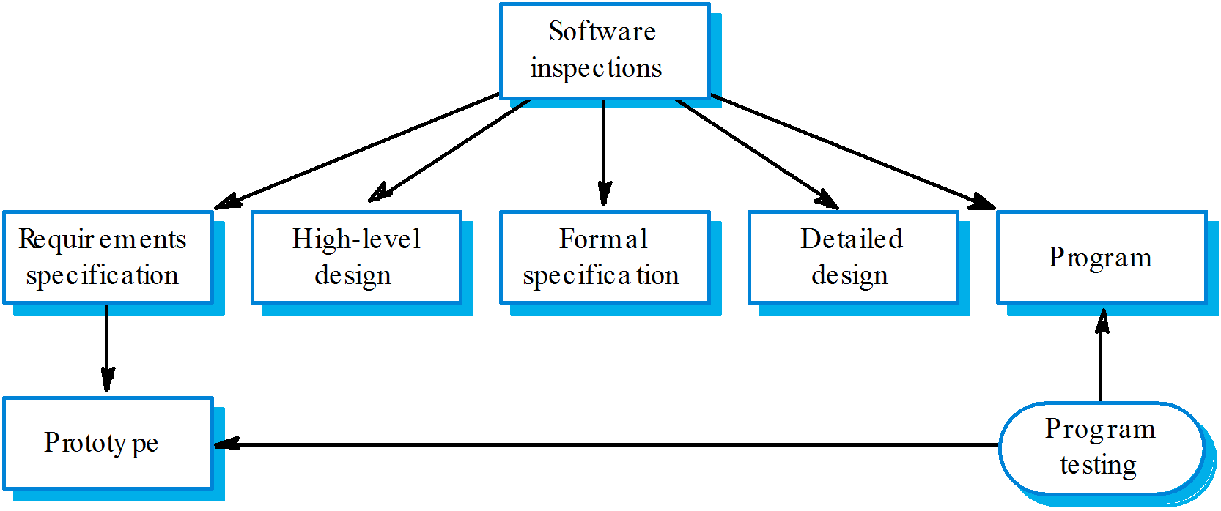Static and dynamic V&V

©Ian Sommerville 2004 Software Engineering, 7th edition. Chapter 22 Slide 10

Program testing

- Can reveal the presence of errors NOT their absence.
- The only validation technique for non- functional requirements as the software has to be executed to see how it behaves.
- Should be used in conjunction with static verification to provide full V&V coverage.

©Ian Sommerville 2004 Software Engineering, 7th edition. Chapter 22 Slide 11

Types of testing

- Defect testing
  - Tests designed to discover system defects.
  - A successful defect test is one which reveals the
presence of defects in a system.
  - Covered in Chapter 23
- Validation testing
  - Intended to show that the software meets its requirements.
  - A successful test is one that shows that a requirement has been properly implemented.

©Ian Sommerville 2004 Software Engineering, 7th edition. Chapter 22 Slide 12

Testing and debugging

- Defect testing and debugging are distinct processes.
- Verification and validation is concerned with establishing the existence of defects in a program.
- Debugging is concerned with locating and repairing these errors.
- Debugging involves formulating a hypothesis about program behaviour then testing these hypotheses to find the system error.

©Ian Sommerville 2004 Software Engineering, 7th edition. Chapter 22 Slide 13

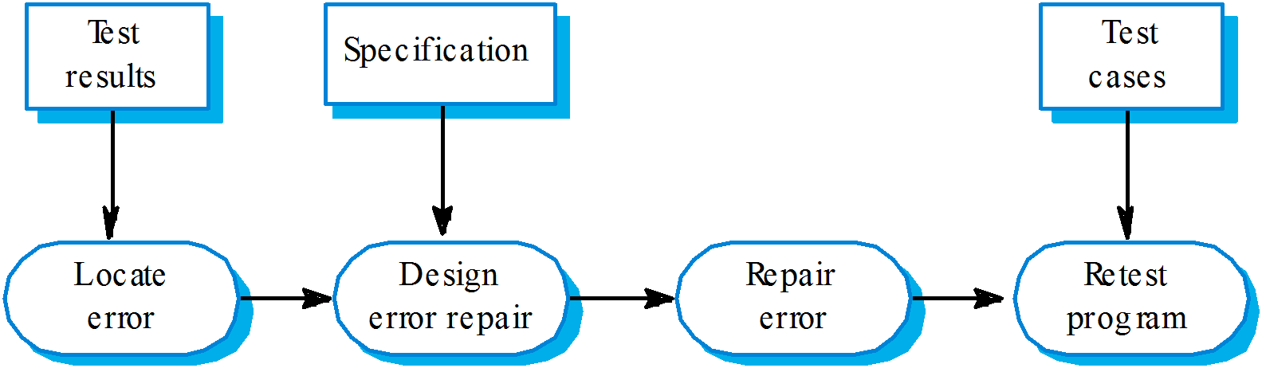The debugging process

©Ian Sommerville 2004 Software Engineering, 7th edition. Chapter 22 Slide 14

V & V planning

- Careful planning is required to get the most out of testing and inspection processes.
- Planning should start early in the development process. (V Model Development !!!)
- The plan should identify the balance between static verification and testing.
- Test planning is about defining standards for the testing process rather than describing product tests.

©Ian Sommerville 2004 Software Engineering, 7th edition. Chapter 22 Slide 15

The V-model of development

©Ian Sommerville 2004 Software Engineering, 7th edition. Chapter 22 Slide 16

The structure of a software test plan

- The testing process.
- Requirements traceability.
- Tested items.
- Testing schedule.
- Test recording procedures.
- Hardware and software requirements.
- Constraints.

©Ian Sommerville 2004 Software Engineering, 7th edition. Chapter 22 Slide 17

The software test plan

The testing process
A description of the major phases of the testing process. These might be as described earlier in this chapter.

Requirements traceability
Users are most interested in the system meeting its requirements and testing should be planned so that all requirements are individually tested.

Tested items
The products of the software process that are to be tested should be specified.

Testing schedule
An overall testing schedule and resource allocation for this schedule. This, obv iously, is linked to the more general project development schedule.

Test recording procedures
It is not enough simply to run tests. The results of the tests must be systematically recorded. It must be possible to audit the testing process to check that it been carried out correctly.

Hardware and software requirements
This section should set out software tools required and estimated hardware utilisation.

Constraints
Constraints affecting the testing process such as staff shortages should be anticipated in this section.

©Ian Sommerville 2004 Software Engineering, 7th edition. Chapter 22 Slide 18

Software inspections

- These involve people examining the source representation with the aim of discovering anomalies and defects.
- Inspections do not require execution of a system so may be used before implementation.
- They may be applied to any representation of the system (requirements, design,configuration data, test data, etc.).
- They have been shown to be an effective technique for discovering program errors.

©Ian Sommerville 2004 Software Engineering, 7th edition. Chapter 22 Slide 19

Inspection success

- Many different defects may be discovered in a single inspection. In testing, one defect may mask another so several executions are required.
- The reuse domain and programming knowledge are essential so reviewers are likely to have seen the types of error that commonly arise.

©Ian Sommerville 2004 Software Engineering, 7th edition. Chapter 22 Slide 20

Inspections and testing

- Inspections and testing are complementary and not opposing verification techniques.
- Both should be used during the V & V process.
- Inspections can check conformance with a specification but not conformance with the customer’s real requirements.
- Inspections cannot check non-functional characteristics such as performance, usability, etc.

©Ian Sommerville 2004 Software Engineering, 7th edition. Chapter 22 Slide 21

Program inspections

- Formalised approach to document reviews
- Intended explicitly for defect detection (not correction).
- Defects may be logical errors, anomalies in the code that might indicate an erroneous condition (e.g. an uninitialised variable) or non-compliance with standards.

©Ian Sommerville 2004 Software Engineering, 7th edition. Chapter 22 Slide 22

Inspection pre-conditions

- A precise specification must be available.
- Team members must be familiar with the organisation standards.
- Syntactically correct code or other system representations must be available.
- An error checklist should be prepared.
- Management must accept that inspection will increase costs early in the software process.
- Management should not use inspections for staff
appraisal ie finding out who makes mistakes.

©Ian Sommerville 2004 Software Engineering, 7th edition. Chapter 22 Slide 23

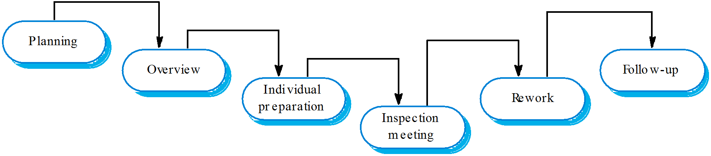The inspection process

©Ian Sommerville 2004 Software Engineering, 7th edition. Chapter 22 Slide 24

Inspection procedure

- System overview presented to inspection team.
- Code and associated documents are distributed to inspection team in advance.
- Inspection takes place and discovered errors are noted.
- Modifications are made to repair discovered errors.
- Re-inspection may or may not be required.

©Ian Sommerville 2004 Software Engineering, 7th edition. Chapter 22 Slide 25

Inspection roles

Author or owner The programmer or designer responsible fo r
producing the program or document. Responsible for fixing defects discovered during the inspection process.
Inspector Finds errors, omissions and inconsistencies in programs and documents. May also identify broader issues that are outside the scope of the inspection team.
Reader Presents the code or document at an inspection meeting.
Scribe Records the results of the inspection meeting. Chairman or moderator Manages the process and facilitates the inspection.
Reports process results to the Chief moderator.
Chief moderator Responsible for inspection process improvements,
checklist updating, standards development etc.

©Ian Sommerville 2004 Software Engineering, 7th edition. Chapter 22 Slide 26

Inspection checklists

- Checklist of common errors should be used to drive the inspection.
- Error checklists are programming language dependent and reflect the characteristic errors that are likely to arise in the language.
- In general, the 'weaker' the type checking, the larger
the checklist.
- Examples: Initialisation, Constant naming, loop termination, array bounds, etc.

©Ian Sommerville 2004 Software Engineering, 7th edition. Chapter 22 Slide 27

Inspection checks 1

Data fa ults Are all program variables initialised before their values are used?
Have all constants been named?
Should the upper bound of arrays be equal to the size of the array or Size -1?
If character strings are used, is a de limiter explicitly assigned?
Is there any possibility of buffer overflow?
Control fa ults For each conditional statement, is the condition correct?
Is eac h loop certain to terminate?
Are compound statements correctly bracketed?
In case statements, are all possible cases accounted for?
If a break is required after each case in case statements, has it been included?
Input/output faults Are all input variables used?
Are all output variables assigned a value before they are output?
Can unexpected inputs cause corruption?

©Ian Sommerville 2004 Software Engineering, 7th edition. Chapter 22 Slide 28

Inspection checks 2

Interface faults Do all function and method calls have the correct number of parameters?
Do fo rmal and actual parameter types match? Are the parameters in the right order?
If components access shared memory, do they have the same model of the shared memory structure?

Storage management faults

Exception management faults
If a linked structure is modified, have all links been correctly reassigned?
If dynamic storage is used, has space been allocated correctly?
Is space explicitly de-allocated after it is no longer required?
Have all possible error conditions been taken into account?

©Ian Sommerville 2004 Software Engineering, 7th edition. Chapter 22 Slide 29

Inspection rate

- 500 statements/hour during overview.
- 125 source statement/hour during individual preparation.
- 90-125 statements/hour can be inspected.
- Inspection is therefore an expensive process.
- Inspecting 500 lines costs about 40 man/hours effort - about £2800 at UK rates.

©Ian Sommerville 2004 Software Engineering, 7th edition. Chapter 22 Slide 30

Automated static analysis

- Static analysers are software tools for source text processing.
- They parse the program text and try to discover potentially erroneous conditions and bring these to the attention of the V & V team.
- They are very effective as an aid to inspections - they are a supplement to but not a replacement for inspections.

©Ian Sommerville 2004 Software Engineering, 7th edition. Chapter 22 Slide 31

Static analysis checks

Fault class Static analysis check
Data fa ults Variables used befo re initialisation Variables declared but never used
Variables assigned twice but never used between assignments
Possible array bound violations Undeclared variables
Control fa ults Unreachable code
Unconditional branches into loops
Input/output faults Variables output twice with no intervening
assignment
Interface faults Parameter type mismatches Parameter number mismatches
Non-usage of the results of functions Uncalled functions and procedures

Storage management faults
Unassigned pointers Pointer arithmetic

©Ian Sommerville 2004 Software Engineering, 7th edition. Chapter 22 Slide 32

Stages of static analysis

- Control flow analysis. Checks for loops with multiple exit or entry points, finds unreachable code, etc.
- Data use analysis. Detects uninitialised variables, variables written twice without an intervening assignment, variables which are declared but never used, etc.
- Interface analysis. Checks the consistency of routine and procedure declarations and their use

©Ian Sommerville 2004 Software Engineering, 7th edition. Chapter 22 Slide 33

Stages of static analysis

Information flow analysis. Identifies the dependencies of output variables. Does not detect anomalies itself but highlights information for code inspection or review
Path analysis

LINT static analysis

138% more lint_ex.c #include <stdio.h> printarray (Anarray) int Anarray;
{ printf(“%d”,Anarray); }

main ()
{
int Anarray [5]; int i; char c; printarray (Anarray, i, c); printarray (Anarray) ;
}

139% cc lint_ex.c 140% lint lint_ex.c

lint_ex.c(10): warning: c may be used before set lint_ex.c(10): warning: i may be used before set printarray: variable # of args. lint_ex.c(4) :: lint_ex.c(10)
printarray, arg. 1 used inconsistently lint_ex.c(4) :: lint_ex.c(10) printarray, arg. 1 used inconsistently lint_ex.c(4) :: lint_ex.c(11) printf returns value which is always ignored

Use of static analysis

- Particularly valuable when a language such as C is used which has weak typing and hence many errors are undetected by the compiler,
- Less cost-effective for languages like Java that have strong type checking and can therefore detect many errors during compilation.

©Ian Sommerville 2004 Software Engineering, 7th edition. Chapter 22 Slide 36

Verification and formal methods

- Formal methods can be used when a mathematical specification of the system is produced.
- They are the ultimate static verification technique.
- They involve detailed mathematical analysis of the specification and may develop formal arguments that a program conforms to its mathematical specification.

©Ian Sommerville 2004 Software Engineering, 7th edition. Chapter 22 Slide 37

Arguments for formal methods

- Producing a mathematical specification requires a detailed analysis of the requirements and this is likely to uncover errors.
- They can detect implementation errors before testing when the program is analysed alongside the specification.

©Ian Sommerville 2004 Software Engineering, 7th edition. Chapter 22 Slide 38

Arguments against formal methods

- Require specialised notations that cannot be understood by domain experts.
- Very expensive to develop a specification and even more expensive to show that a program meets that specification.
- It may be possible to reach the same level of confidence in a program more cheaply using other V & V techniques.

©Ian Sommerville 2004 Software Engineering, 7th edition. Chapter 22 Slide 39

Cleanroom software development

- The name is derived from the 'Cleanroom' process in semiconductor fabrication. The philosophy is defect avoidance rather than defect removal.
- This software development process is based on:
  - Incremental development;
  - Formal specification;
  - Static verification using correctness arguments;
  - Statistical testing to determine program reliability.

©Ian Sommerville 2004 Software Engineering, 7th edition. Chapter 22 Slide 40

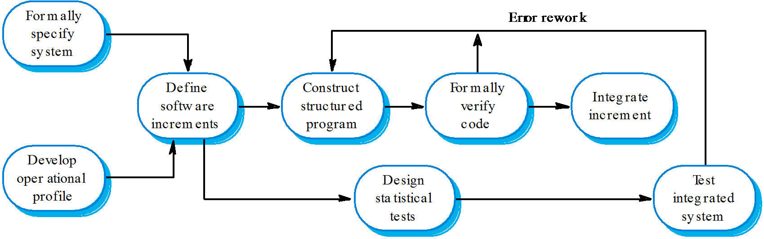The Cleanroom process

©Ian Sommerville 2004 Software Engineering, 7th edition. Chapter 22 Slide 41

Cleanroom process characteristics

- Formal specification using a state transition model.
- Incremental development where the customer prioritises increments.
- Structured programming - limited control and abstraction constructs are used in the program.
- Static verification using rigorous inspections.
- Statistical testing of the system (covered in Ch. 24).

©Ian Sommerville 2004 Software Engineering, 7th edition. Chapter 22 Slide 42

Formal specification and inspections

- The state based model is a system specification and the inspection process checks the program against this model.
- The programming approach is defined so that the correspondence between the model and the system is clear.
- Mathematical arguments (not proofs) are used to increase confidence in the inspection process.

©Ian Sommerville 2004 Software Engineering, 7th edition. Chapter 22 Slide 43

Cleanroom process teams

- Specification team. Responsible for developing and maintaining the system specification.
- Development team. Responsible for developing and verifying the software. The software is NOT executed or even compiled during this process.
- Certification team. Responsible for developing a set of statistical tests to exercise the software after development. Reliability growth models used to determine when reliability is acceptable.

©Ian Sommerville 2004 Software Engineering, 7th edition. Chapter 22 Slide 44

Cleanroom process evaluation

- The results of using the Cleanroom process have been very impressive with few discovered faults in delivered systems.
- Independent assessment shows that the process is no more expensive than other approaches.
- There were fewer errors than in a 'traditional'
development process.
- However, the process is not widely used. It is not clear how this approach can be transferred
to an environment with less skilled or less
motivated software engineers.

©Ian Sommerville 2004 Software Engineering, 7th edition. Chapter 22 Slide 45

Key points

- Verification and validation are not the same thing. Verification shows conformance with specification; validation shows that the program meets the customer’s needs.
- Test plans should be drawn up to guide the testing process.
- Static verification techniques involve examination and analysis of the program for error detection.

©Ian Sommerville 2004 Software Engineering, 7th edition. Chapter 22 Slide 46

Key points

- Program inspections are very effective in discovering errors.
- Program code in inspections is systematically
checked by a small team to locate software faults.
- Static analysis tools can discover program anomalies which may be an indication of faults in the code.
- The Cleanroom development process depends on incremental development, static verification and statistical testing.

©Ian Sommerville 2004 Software Engineering, 7th edition. Chapter 22 Slide 47

